Clinical Feedback meeting notes by Goutam Reddy (greddy@abiogenix.com)

3/23/20 meeting @ Stanford Health

Interviewed: Dr. Linda Barman, Thanh Khong PAC (they run the drive-through swabbings)

Summary of Design Notes:

1. Features too sharp => need a smoother edge (like flocking) - suggested a “rounded Archimedes screw”
2. Need a rounder tip (like bulb of flocked head) w/ “cupping”
3. Need to stiffen break-point and move back
4. Need plastic to bend but not deform => spring back after bending (liked thicker diameter neck models than thinner)
5. Most liked designs #3, #10, #1
6. Finer features not showing up in PA12 prints (PA11 vs PA12?)

Swab Note:

They use a swab with a longer cut-off point. She said our cut-off point was too short (nasal swab vs. nasopharyngeal swab?) Measurements of the swabs they use below:

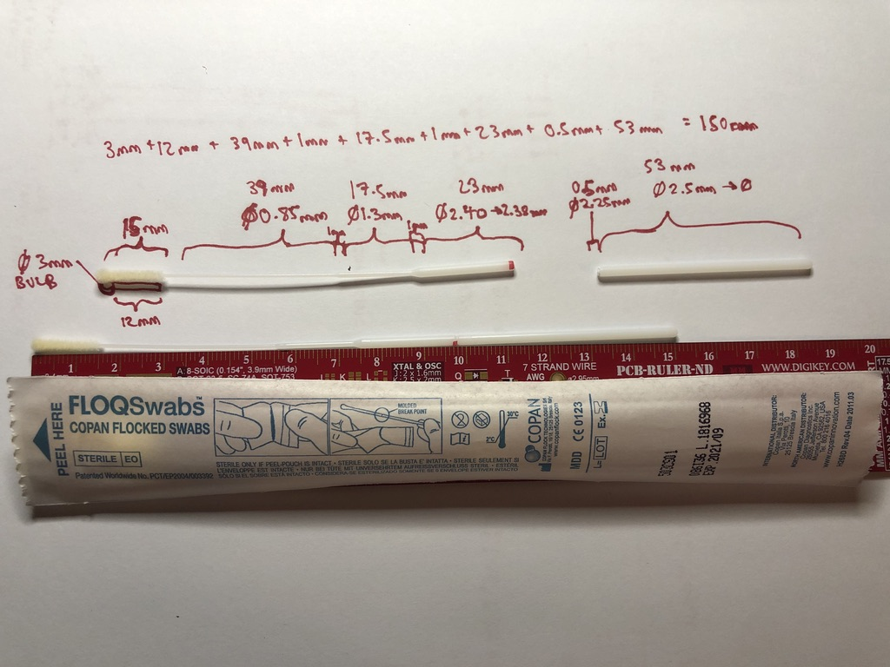

General Notes:

1. We should test temperature changes of our swabs as they can be sitting in freezing temperatures for drive-through clinics.
2. Asked about sterilization and packaging -> is it autoclavable?
3. Nasopharyngeal space is extremely sensitive (to bleeding, irritation etc…), especially in patients coming in to be swabbed. Err on the side of doing no harm (i.e. swabbing is not a life-saving intervention => we’ll be doing millions of swabs => err on side of gentle np swab and no damage to tissues (no poking, soft interface, no breaking off inside so ENT has to extract)

Test 1) Abiogenix Nubs w/ Holes in PA11 (mfg by HP in San Diego)

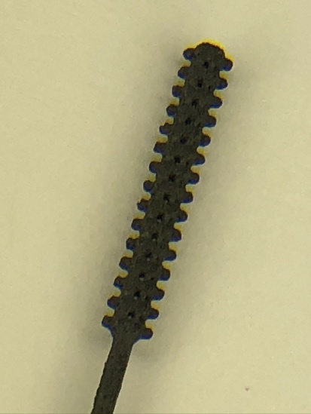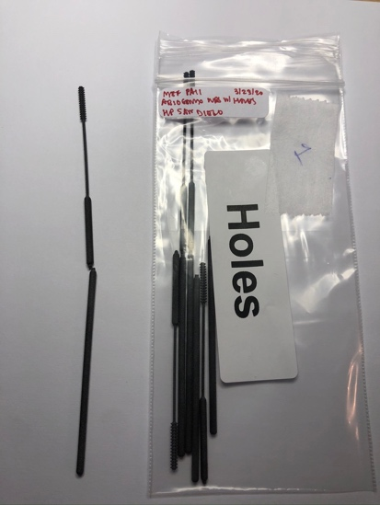

* too flimsy @ breakoff point => stiffen @ breakoff
* breakpoint too far down
* too rough

Test 2) Abiogenix Nubs w/o Holes in PA11 (mfg by HP in San Diego)

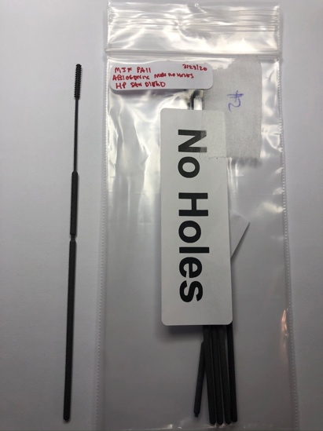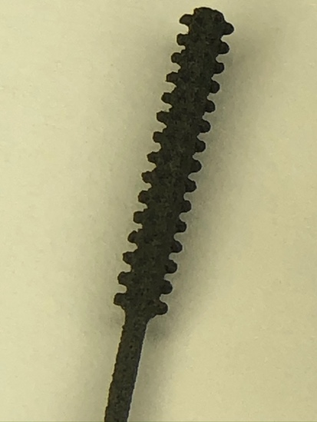

* needs rounded tip like the bulb on the flocked swab
* tip is too tiny: needs absorption
* passage to nasopharynx has bends, so swab needs to bend but needs to spring back

Test 3) Fathom ??? in PA12 (mfg by Fathom in Oakland)

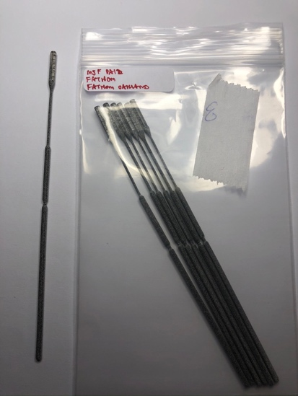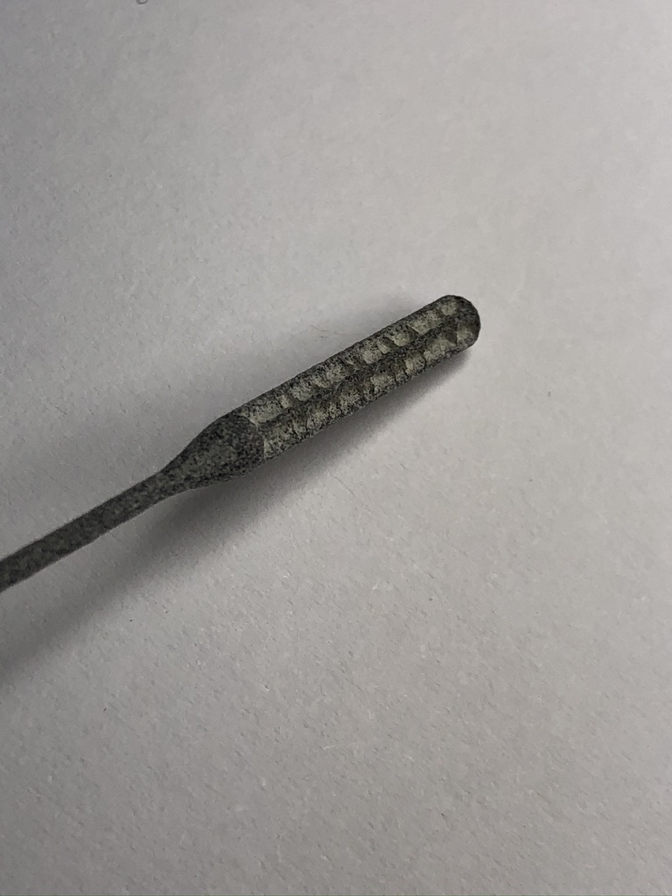

* liked round tip
* smooth out
* make neck longer
* good size
* good front
* good neck

Test 4) Fathom ??? in PA12 (mfg by Fathom in Oakland)

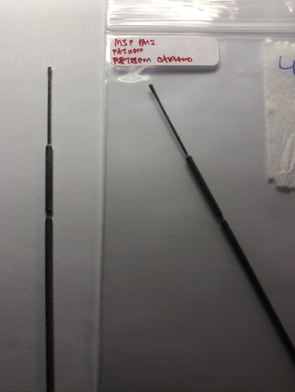

* too brittle
* ripped off tip
* too small
* too thin
* not sure which one this was – check inventory of prints from 3/23/20

Test 5) Fathom ??? in PA12 (mfg by Fathom in Oakland)

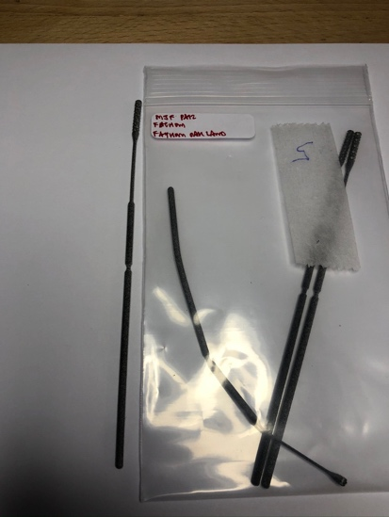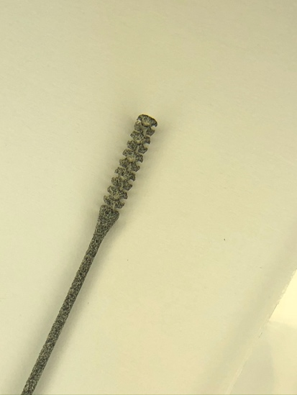

* heads breaking off
* “medieval torture device”
* shaft too brittle

Test 6) Abiogenix Nubs in PA12 (mfg by Fathom in Oakland)

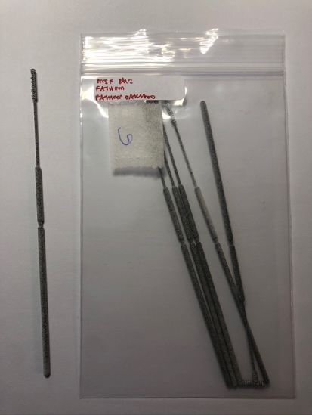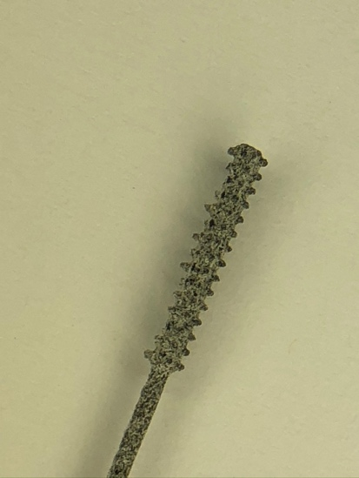

* “weapon”
* shaft breaking
* in general: needs rebound: needs higher elasticity

Test 7 & 8) Abiogenix Round Tip in PA12 (mfg by Fathom in Oakland)

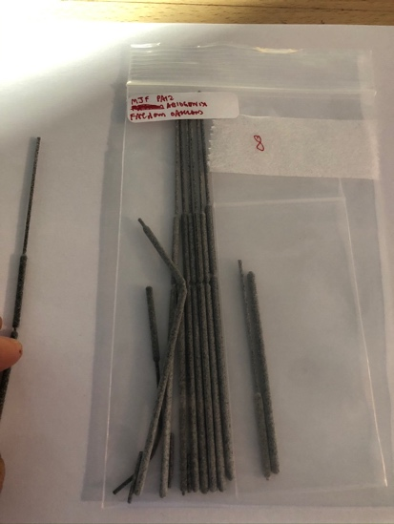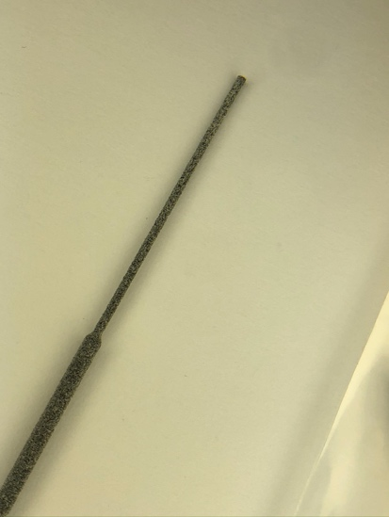

* no notes

Test 9) Fathom ??? in PA12 (mfg by Fathom in Oakland)

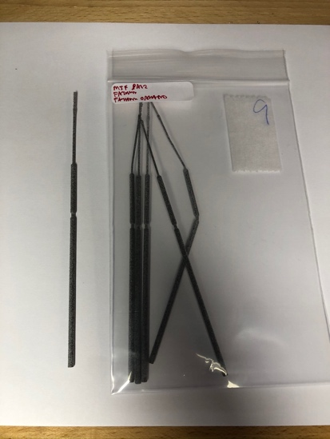 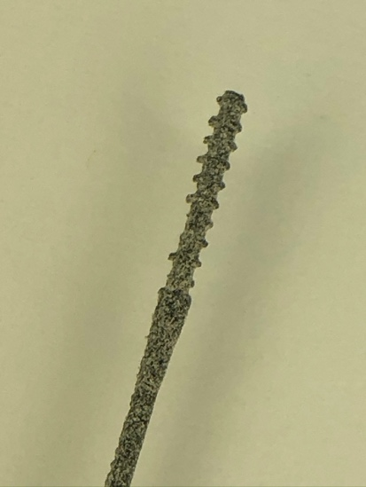

* Tip ripped off
* Too small
* Too thin

Test 10) Wyss Balls in PA12 (mfg by Fathom in Oakland)

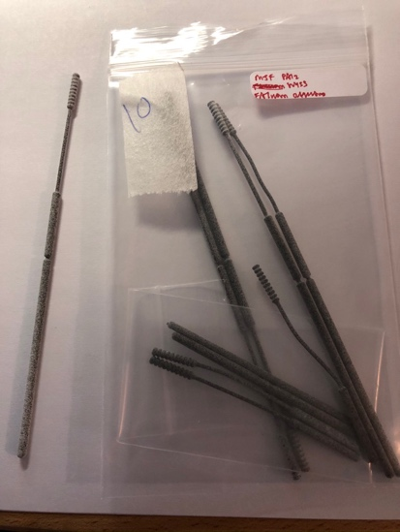 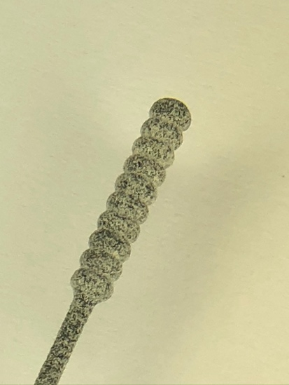

* “head too wide”
* like roundness
* suggested archimedes screw => rounded w/ cupping and capture fluid,   
  like a “staircase with smooth edges”